Blog by Jonathan Winter – Information Assistant at Cass
On the 19th October 2016, I attended the 'Professional Identity and Development for Librarians' event at the British Library, where I took part in a course about the future identities of librarians, and subsequently will be presenting findings at the next staff symposium. This event examined the profession's core skills and identity, how we and others view the profession, and helped us consider development plans, as librarians, for the future.
It was held in the eminent board room, on the 4th floor of the British Library. I was looked down upon by oil paintings of past librarians, who seemed to scrutinise me.
The first session was on professional identities by Kathy Ennis, a previous CILIP employee who has now set up her own consultancy business, Little Piggy UK. She challenged us to combat the stereotype of the librarian (glasses, cardigan, and cats) that remains, with the information expert, the librarian of today, and how to best present ourselves. This is a summary of what she told us:
As times have changed, our visual literacy skills have developed. To illustrate this, advertising has become shorter, and uses our assumptions to summarise more and more. For example, images on Facebook get ten times as many hits as text does. She spoke about impression management and sensation transference developed by Erving Goffman in the 1950’s. He stated that humans are like chameleons. Impression management, he said, is a process ‘by which people in social situations manage the setting and their dress, words and gestures to correspond to the impressions they are trying to make or the image they are trying to project’. Kathy also spoke about Gladwell’s (2005) book: Blink, who wrote about the power of first impressions and the importance of body language. Furthermore, Louis Cheskin, the psychologist and marketer, said that people trust what they see before they trust what they hear. They give an assessment of something they might buy without realising it, they transfer sensations: 55% of a first impression is body language, 38% pitch and pace of your voice, and only 7% words/content. This all happens in a seven second window.
She summarised by urging us not to create a separate persona, and to mirror people’s expectations. She summarised that consistency builds congruency.
In our work, we are judged:
30% on appearance and body language
30% on the quality of the work produced
30% on being seen to be a good job
10% on doing your job!
The second speaker was Helen Berry, Development Officer CILIP. Her presentation was: Who you want to be and become - Tools to help you build your career, and outlined how CILIP can help. She underlined that career planning comes when we might not expect it to. Change will happen, be it a promotion, transfer, cross-sector move, or a return from career break. We are all going through appraisal time at the moment, so it is a poignant time to think about this. She showed us a range of tools that CILIP offers to help us in our progression as librarians. The CILIP website can help you: http://www.cilip.org.uk/jobs-careers/professional-knowledge-skills-base and is good if an interview is coming or for career planning. Also they have member networks – both regional and special interest. It is interesting to note that you can also get bursaries to pay for conferences or get experience through committee work. All this is useful for professional development and also as a confidence raiser.
The CILIP website has a new part – the careers HUB. This helps with managing your career, and tells you which academic range of jobs exist. If you are part of CILIP, you can submit an audio interview to add to website saying what you do. Lastly, she talked about becoming a mentor or having mentoring. You can do your Chartership, your Revalidation or a Fellowship.
The third and last speaker was David White, head of Digital Learning at the Teaching and Learning Exchange at the University of the Arts, London. He talk was on: Being Present in the Digital Era. His message for libraries was: ‘We should create open and transdisciplinary opportunities for students to come together in face-to-face and virtual spaces as part of a community’. He said that digital and physical spaces coexist. It’s a mixed scenario in a library (journals laptops books notepads smart phones ipads). He expressed that digital technology is about people and a set of relationships or connections, encompassing everything, which includes such daily activities as resource searching.
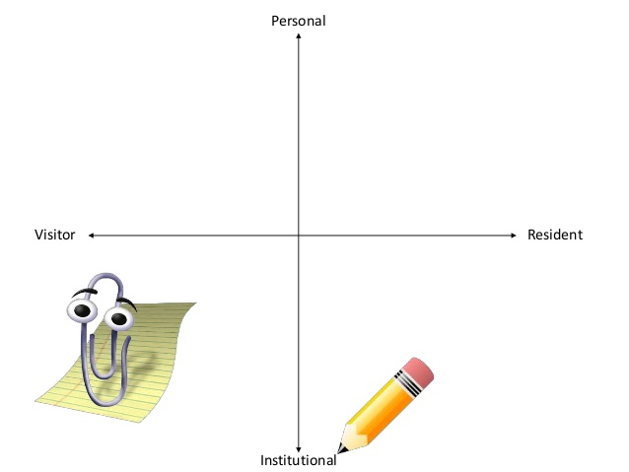
He spoke about: When you are engaging online are you a visitor or a resident? Is it not useful to ask: are you using twitter? As this is now a 24/7 activity. It would be better to ask: how are you using twitter/fb? He described the difference between the institutional voice and the personal voice. For example, if you use twitter as the Library, then the library answers and not a person. Here is a graph which describes activities in the digital environment:

For example, when using Moodle, you would be an institutional visitor and you would be in the bottom left quadrant. Whereas, managing a library twitter feed you would be in the part of an institutional and a resident. Social media and digital resident spaces depend on the personal. The academic world has changed, he said. Authentic validity of a professional now has to be personal. He summarised that: we are collections of human beings, and perhaps all librarians should become a digital resident in some form or other. Interestingly for us, he also talked about the Academic-Librarian relationship. Academics don’t have time to treat librarians as fellow experts, it is not that they don’t respect them. The digital environment is a place where this discourse can happen. It is hard, he said, to get an angle on the expertise that exists in the library. The digital environment is a place are where you can find this out.
Gladwell, M. (2005) Blink: The Power of Thinking Without Thinking. London: Penguin.
Goffman, E. (1959) The Presentation of Self in Everyday Life. London: Penguin.
Image taken from Lynn Connaway’s page on LinkedIn. Available at: http://www.slideshare.net/LynnConnaway/digital-visitors-and-residents-interactive-mapping-exercise (Accessed 16 November 2016).

