ICERI (International Conference on Education Research and Innovation.)
Seville November 19th and 20th 2013
As part of the dissemination activity for our learning development project funded by the LDC the three researchers on the project, Karen Rawlings- Anderson, Natasa Perovic and Neal Sumner attended this conference in Seville to present some of our findings to an international audience. We chose this conference because it had a clear theme on the uses of educational technology, the focus of our project, and offered a global audience (there were over 600 delegates drawn from around the world).
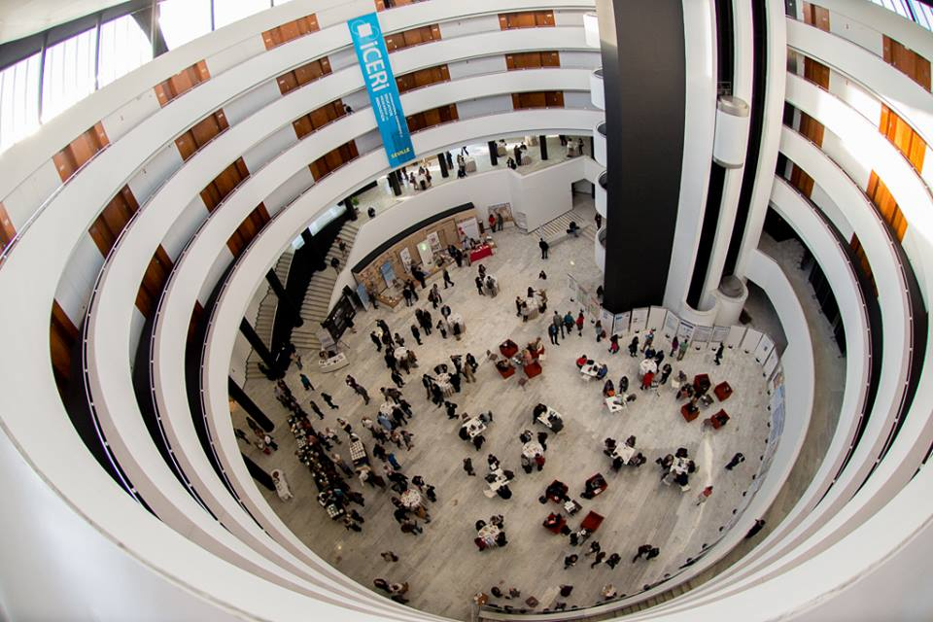
The Conference Venue
Our paper, entitled ‘Finding the Blend: an evaluation of the balance between online and face to face leaning and teaching in a blended curriculum’ was based on research carried out on the design and implementation of a new Nursing curriculum in 2012 here at City University London. (A fuller version of the paper will appear in a forthcoming volume of the Learning at City Journal).
Although the paper could have been allocated into several of the conference threads, including Blended Learning, Flipped Classroom or Technical Innovations in Learning and Teaching, in fact we found ourselves allocated to present under the Technology in Health Sciences strand, which was one of the more popular and continuing the threads throughout the conference. As such we had a good audience for our session, which was - judging by the comments and questions we received afterwards - well received.

There was plenty of interest in the remainder of the conference. Particular highlights for us were a case study on using Point-of-View video glasses for self assessment - again in the context of Nurse education, as well as the use of more familiar technologies such as audio MP3s for providing feedback, the use of VLEs and Virtual Universities. There were interesting sessions on Learning Space design, assessment of student learning, MOOCs and social media as well as four consecutive different poster sessions. One open access tool which impressed was Quizlet, which has multiple applications at a variety of levels. Karen and Neal were interviewed in a TV studio for their opinions on the conference, so this may yet be released for public consumption! An overview of all the sessions, with links through to the abstracts and full papers, can be accessed on this link.
A particular feature of the conference is that it spans all phases of education, from primary, through secondary, Higher Education and lifelong learning: it is clear from the sessions we attended that educational technologies are having a transformative influence on all aspects. Another key feature reflects the global nature of the contributions to the conference - so there was a continuum from those developed parts of the world where technologies have been in use for many years and the challenges are more about how to embed and use technologies to transform pedagogy, to the challenges faced in less developed countries whether problems of access, costs and infrastructure remain serious obstacles to educational and technological development.
Seville was a great venue for a late November conference - the mild climate was a welcome change and the closing night flamenco and tapas provided by the conference organisers gave us a taste of local culture.
